FOR IMMEDIATE PRESS RELEASE

ART LEXÏNG unveils a solo exhibiton “La Habana in Waiting” by New York-based Chinese artist Quentin Shih with Christian Louboutin for 2nd edition of Art Basel Hong Kong 2014

ART LEXÏNG, in collaboration with Christian Louboutin is pleased to announce the exhibition of internationally renowned photographer, Quentin Shih, in the second installment of Art Basel Hong Kong. Following a successful partnership during the inaugural launch of Art Basel Hong Kong last year, Quentin Shih’s solo exhibition, entitled “La Habana in Waiting” will be revealed on May 15th through May 19th at the Christian Louboutin boutique and the neighboring Fringe Club’s Anita Chan Lai-Ling Gallery.

Quentin Shih is recognized worldwide for his theatrical, large format photographs which are subject to a rigorous composition and complex post-production process. His photographs are provocative performances captured in moments of silent turbulence.

In his most recent series, Shih explores the unwritten tensions and melancholy residing in Cuban citizens quietly sitting for an artist's lens. La Habana in Waiting is an
exploration of the polarities between expressive individuals struggling for identity within a Communist regime. The photographer, himself, hails from a similarly body in China; drawing parallels between both experiences living in a creatively constricted environment is essential for Shih.
Through the process of envisioning and creating these photographs, Shih is asking himself – and viewers – a series of questions about the nature of representation, and how our imagination influences that representation. “Is the Cuba of propaganda photographs more authentic?” he says. “Or are the waiting and restless teens who grew up after the revolution more representative of reality? Both of these exist in my experience.”

His silent stages are populated by actors with no scripts, no direction: they exist in a kind of temporal limbo, captured in a film still. Specific to Shih's work is an aesthetic presentation that does not actively disturb or alter the physical appearance of the subjects, as is widely seen in conventional forms of contemporary Chinese painting.

“I greeted and shook hands with each sitter but I was more interested in the process. We were both inquisitive of the other, wondering what exactly we were doing together.” Shih writes so on his tourist identity in Cuba.

Anita Chan Lai-Ling Gallery
Fringe Club, 2 Lower Albert Road, Central
T: 852 2521 7251
Hours: May 15th –May 19th , 12:00pm – 10pm

For further information, press enquiries, images or interview requests, please contact:
Lexing Zhang – Gallery director/ ART LEXÏNG
lexing@artlexing.com / 001 305 299 9732 / www.artlexing.com

EDITORS NOTES

About Quentin Shih

Quentin Shih (Shi Xiaofan) was born in Tianjin in 1975. He graduated from Southeast University in Nanjing in 1998 and participated in the year-long School of Visual Arts' (SVA) PhotoGlobal residency program in 2009. Shih rose to international prominence in 2008 with his celebrated series Stranger In A Glass Box, collaborating with French haute couturier Dior. Shih was the winner in the Fine Arts category of the 2009 Hasselblad Masters Award and was named 2007 Photographer of the Year by Esquire Magazine (China). Shih has participated in solo and group exhibitions at the Ullens Center for Contemporary Art in Beijing, the Museum of Modern Art in Moscow, the Contemporary Art Galleries at the University of Connecticut, the Boca Raton Museum of Art and selected venues in Beijing, Brussels, Paris, Miami, Los Angeles, and Boston. Shih's work is held in the public collections of the 21st Century Museum Louisville in Kentucky, the Worcester Museum of Art and the Danforth Museum of Art in Massachusetts and the Christian Dior Collection in Paris. Shih lives and works in New York City.

About ART LEXÏNG

Miami-based gallery ART LEXÏNG is committed to promoting museum-quality works from emerging Asian artists, each with truly original and challenging perspectives filtered through photography, sculpture and traditional two-dimensional media. Partnering with respected museums and galleries and participating in internationally-acclaimed art fairs throughout the United States, Europe and beyond, ART LEXÏNG strives to present its global audience with only the most forward-thinking, provocative works from Asia's brightest young talents.

About Christian Louboutin

The Christian Louboutin Company was created in 1992 when Louboutin opened his first store at 19 Jean-Jacques Rousseau in Paris. The brand currently has 59 stores worldwide including a number of dedicated Mens boutiques. 2012 marks the 20th anniversary of the company, and to celebrate this milestone, the brand has recently embarked on a number of exciting projects, including the release of a seminal volume entitled ‘Christian Louboutin’, a collaboration with legendary Parisian Cabaret, Crazy Horse and a retrospective exhibition at London’s prestigious Design Museum.

Quentin Shih, Danmaris Fleita
C-print, 112 x 191 cm, 2012

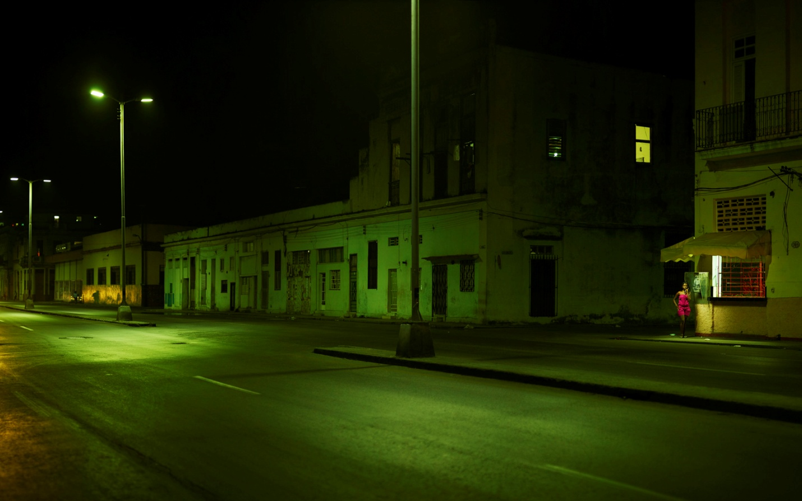

Quentin Shih, Lucia Corrales, Jennifer Vergara & Rachel Magana
C-print, 112 x 191 cm, 2012

